Lapse Letter

July 26, 2024

New York State Joint Commission on Public Ethics
540 Broadway
Albany, NY 12207

ATTN: Lobbying Compliance

We are aware we are prohibited from performing any Lobbying Activity or receiving Compensation for such activities until a completed Statement of Registration is filed with COELIG or The Office of the City Clerk, which includes the filing fee and an executed Lobbying Agreement, or in the event a contract does not exist, a copy of a signed, written Lobbying authorization.

Accordingly, this letter confirms that no Compensation was billed and/or received, nor were any Lobbying Activities performed on behalf of Homeowners for a Stronger New York, Inc between July 1, 2024 and July 14th, 2024 until the Lobbying Agreement was executed by both parties. We are also aware we may be assessed a late filing fee if the Statement of Registration is not submitted to COELIG and The Office of the City Clerk within 10 days of billing and/or receiving Compensation, or 15 days of being retained, employed, or designated to Lobby.

MirRam Group

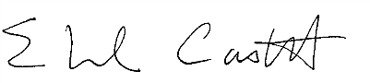 07/26/2024
______________________ _____________
Eduardo Castell, Managing Partner Date

