December 22, 2020

NYS Joint Commission on Public Ethics
540 Broadway
Albany, NY 12207

ATTN: Lobbying Compliance

Re: Written Authorization for Employed Lobbyists

I hereby certify that I, Margaret Gorman, am the Chief Administrative Officer of the American Chemistry Council and that I am duly authorized to execute and deliver this authorization. I hereby authorize and designate the following employees to lobby on behalf of the American Chemistry Council effective January 1, 2021 before all officials, bodies and instrumentalities of New York State during calendar year 2021:

Margaret Gorman
Erin DeSantis

Ms. Gorman and Ms. DeSantis’ lobbying activities in New York on behalf of ACC are to commence on January 1, 2021, and cover the period ending December 31, 2021.

Ms. Gorman will be compensated for her lobbying activity. The anticipated compensation for Ms. Gorman is $105/hr.

Ms. DeSantis will be compensated for her lobbying activity. The anticipated compensation for Ms. DeSantis is $65/hr.

Other services, in addition to lobbying will be provided by the individuals authorized to lobby.

Respectfully submitted,

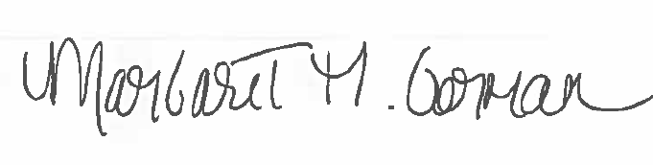

_________________________________
December 21, 2020
Senior Director, Northeast Region

